Combination square
# Source: AI Source: Provided by: [Data Path: Persons Table -> ID Column: 1, Name_En Column: Motasem Essam] -> From: [ChatGPT] on [7/17/2026]
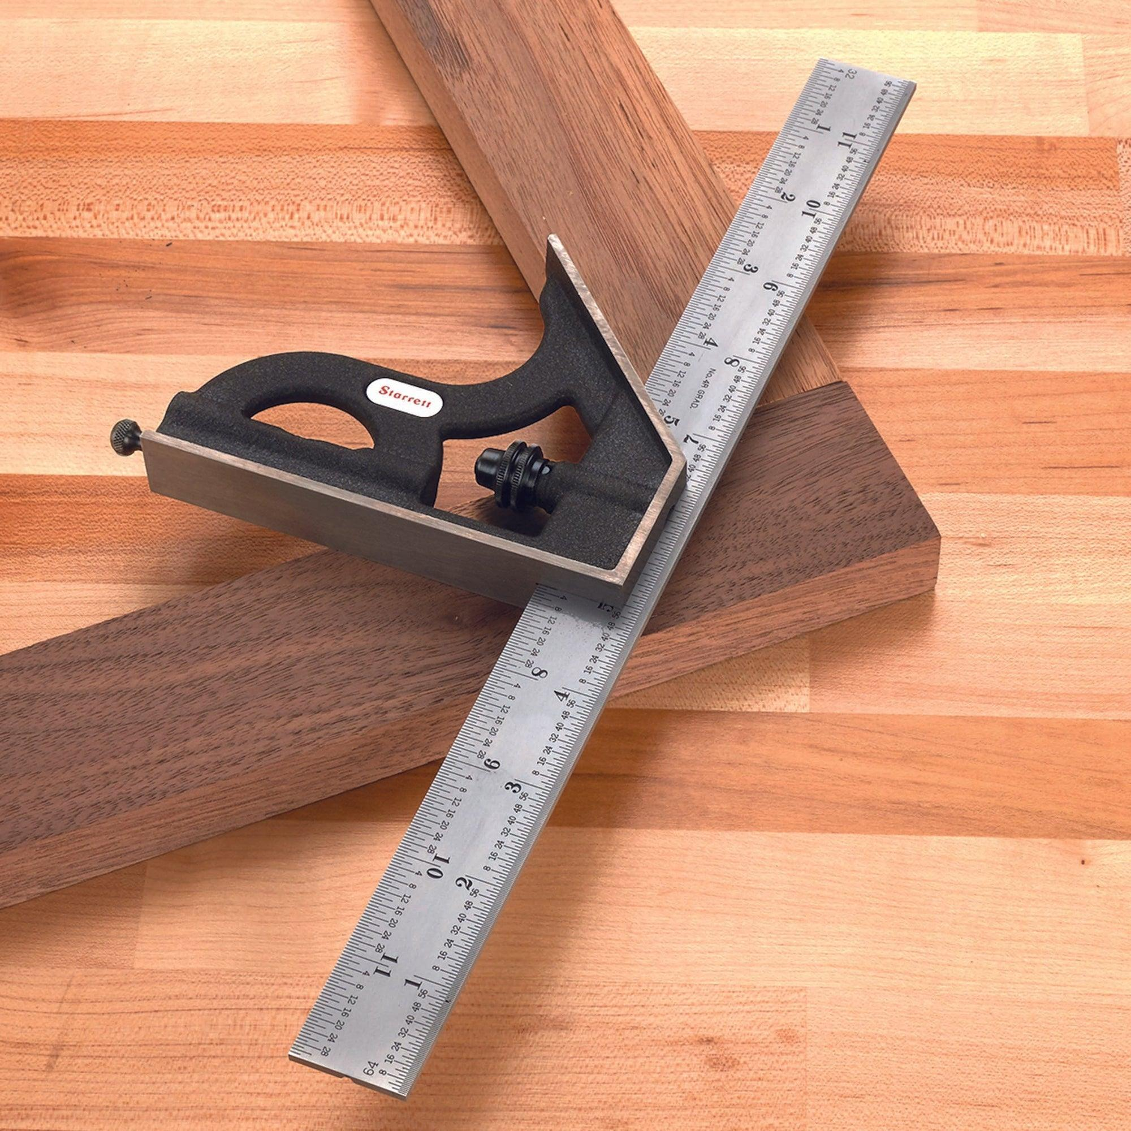
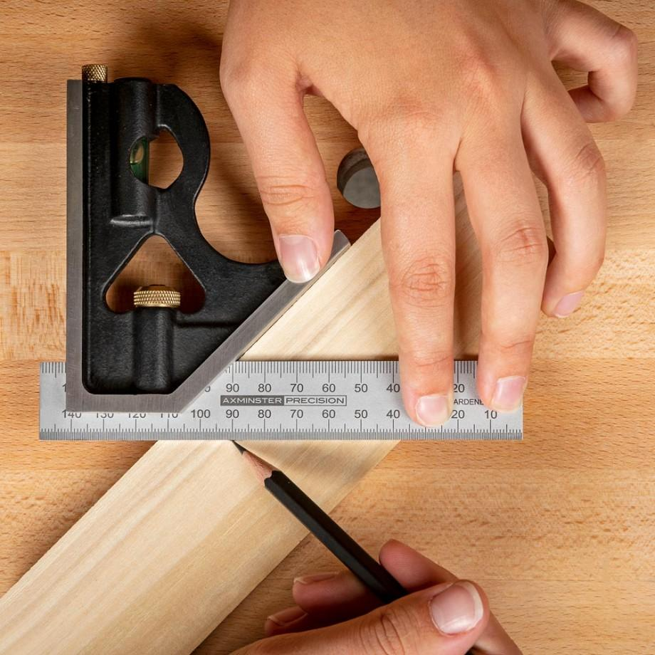
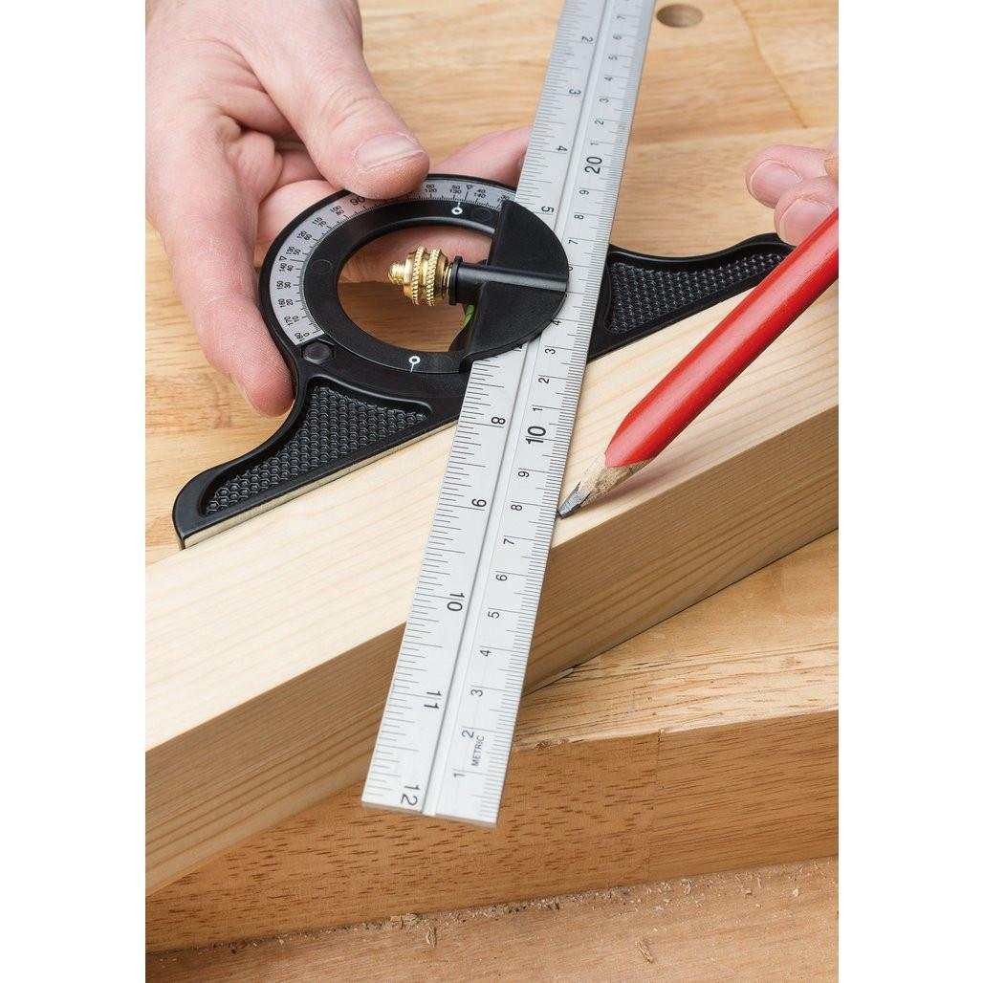
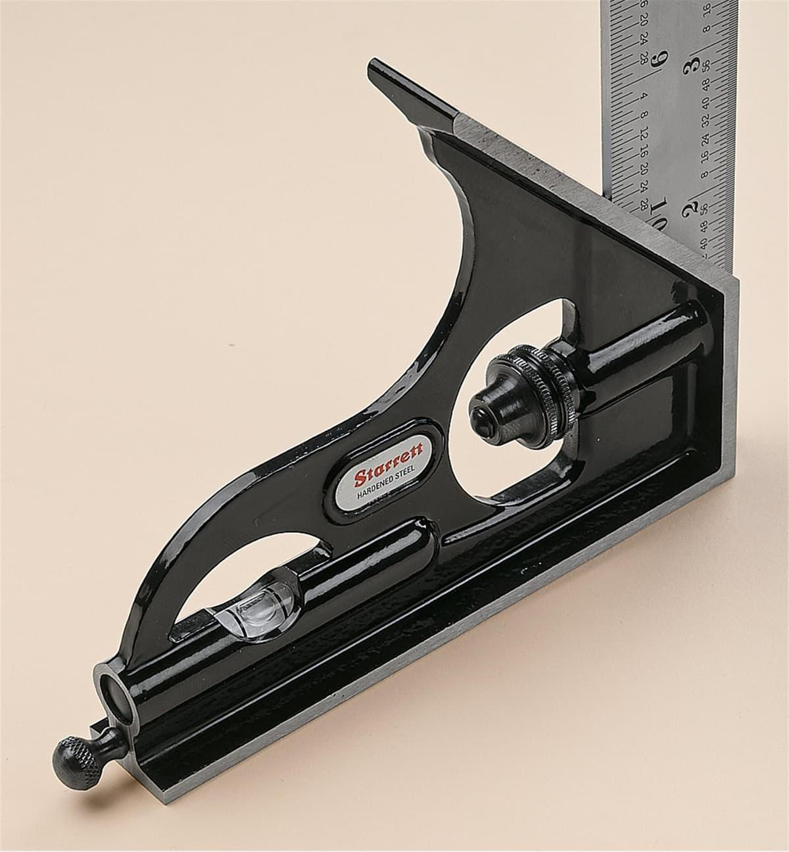
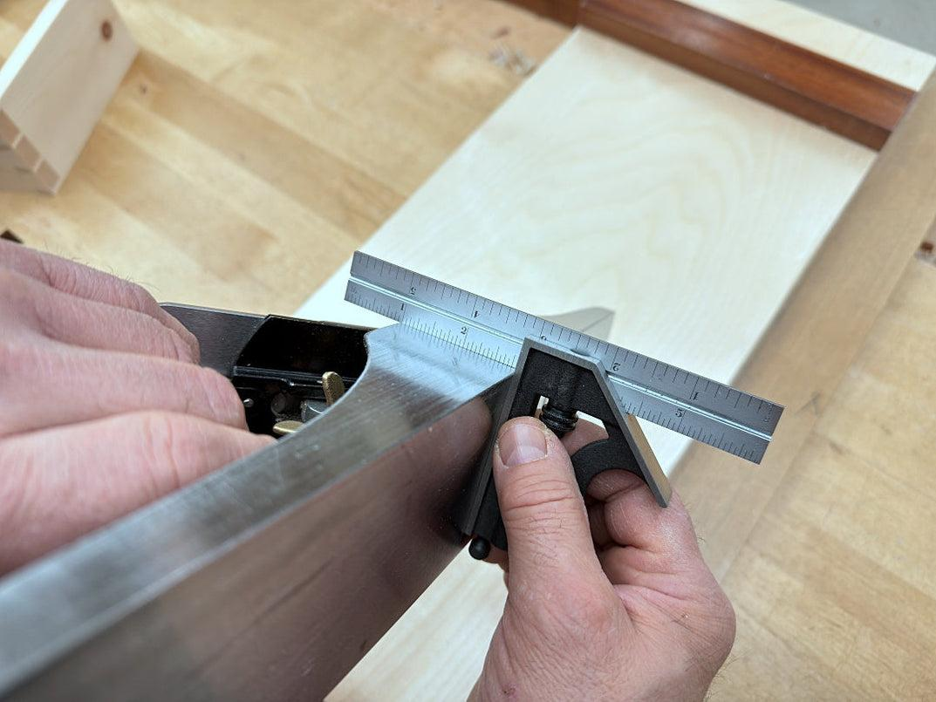
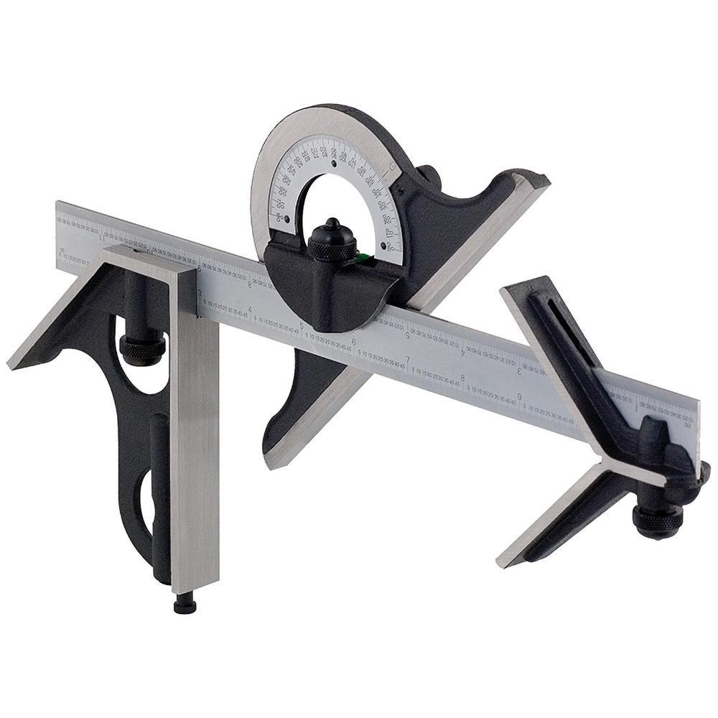
A Combination Square is a multi-purpose precision measuring and marking instrument used to measure angles, lengths, depths, and heights, as well as to check 90° (right angles) and 45° angles. It is one of the most versatile tools used in carpentry, machining, engineering, metalworking, woodworking, and inspection.
The tool consists of a graduated steel rule with interchangeable heads that slide along the rule and can be locked in position.

Definition
# Source: AI Source: Provided by: [Data Path: Persons Table -> ID Column: 1, Name_En Column: Motasem Essam] -> From: [ChatGPT] on [7/17/2026]
A Combination Square is a precision measuring and layout instrument consisting of a graduated steel rule and interchangeable heads used for measuring, marking, and checking angles, depths, and dimensions.

Purpose
# Source: AI Source: Provided by: [Data Path: Persons Table -> ID Column: 1, Name_En Column: Motasem Essam] -> From: [ChatGPT] on [7/17/2026]
A Combination Square is used to:
- Measure linear dimensions.
- Check 90° angles.
- Check 45° angles.
- Measure depth.
- Measure height.
- Mark layout lines.
- Check flatness and straightness.
- Locate the center of cylindrical objects (with a center head).
- Measure adjustable angles (with a protractor head).

Main Components
# Source: AI Source: Provided by: [Data Path: Persons Table -> ID Column: 1, Name_En Column: Motasem Essam] -> From: [ChatGPT] on [7/17/2026]
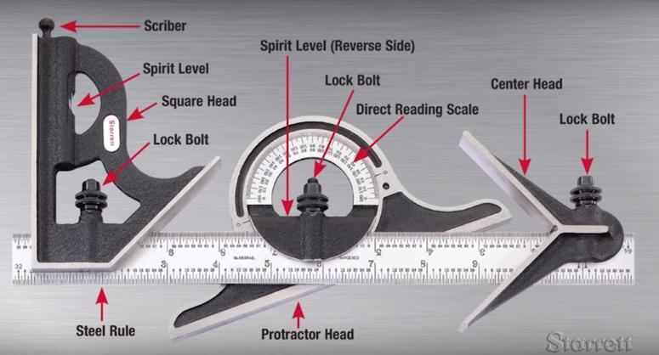
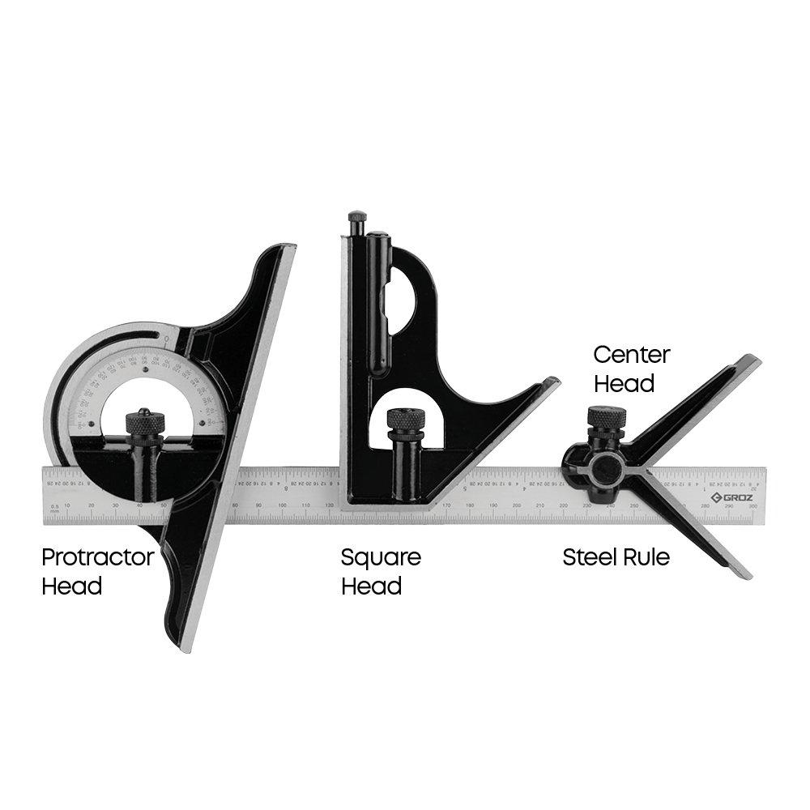
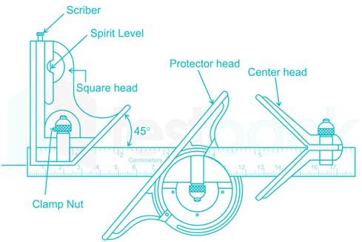
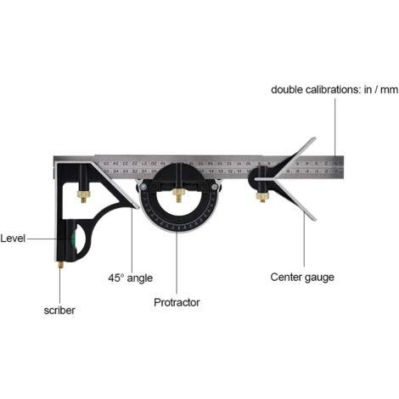
A complete Combination Square set typically consists of:
- Steel Rule
- Square Head
- Protractor Head
- Center Head
- Locking Screw
- Spirit Level (on many square heads)
- Scriber (on many models)

Types of Combination Square Heads

1. Square Head (Standard Head)
# Source: AI Source: Provided by: [Data Path: Persons Table -> ID Column: 1, Name_En Column: Motasem Essam] -> From: [ChatGPT] on [7/17/2026]
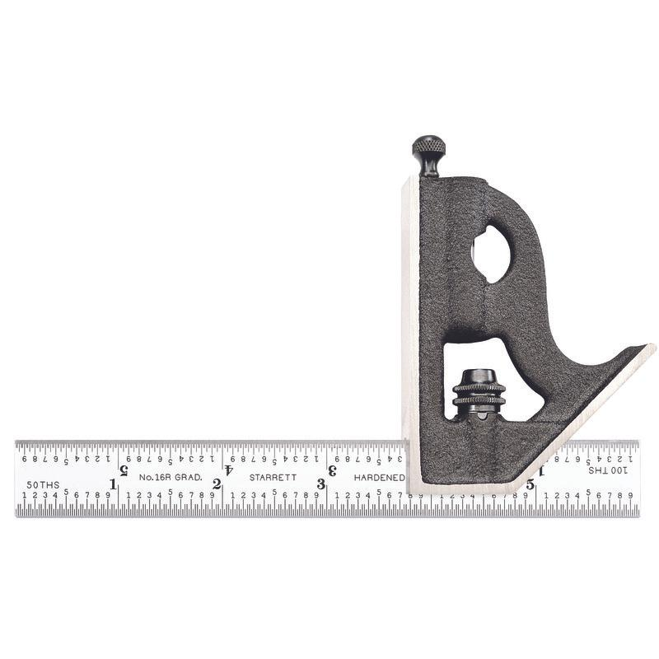
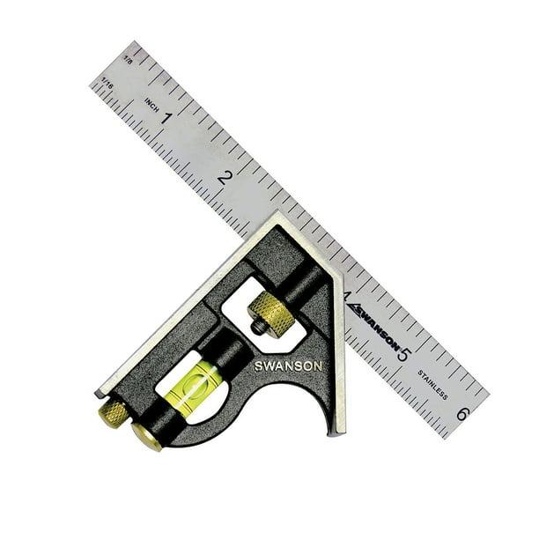
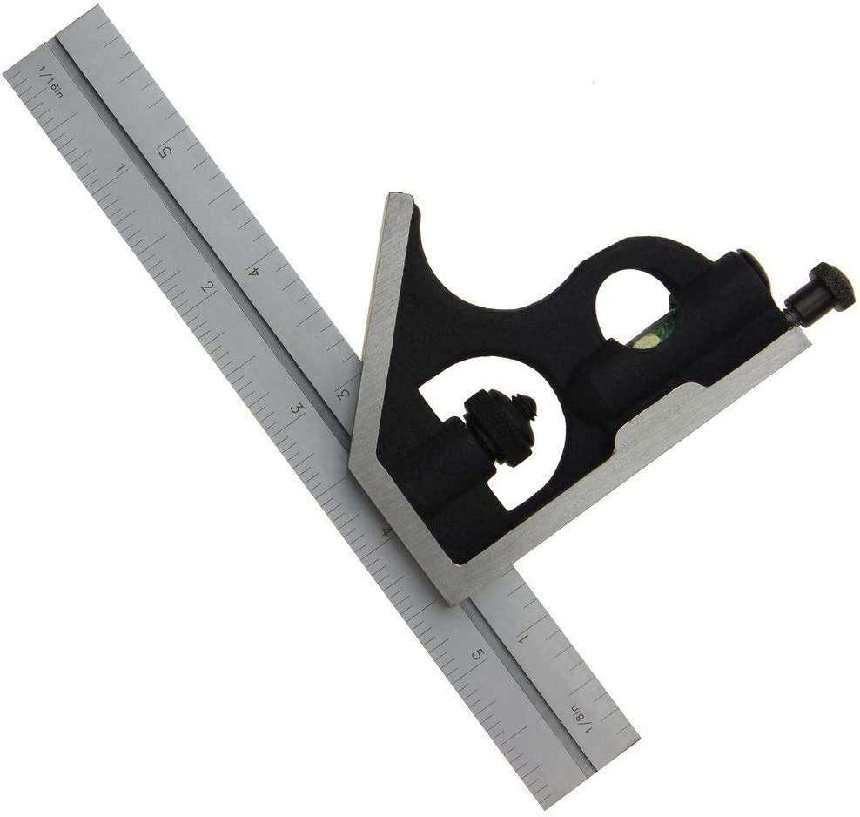
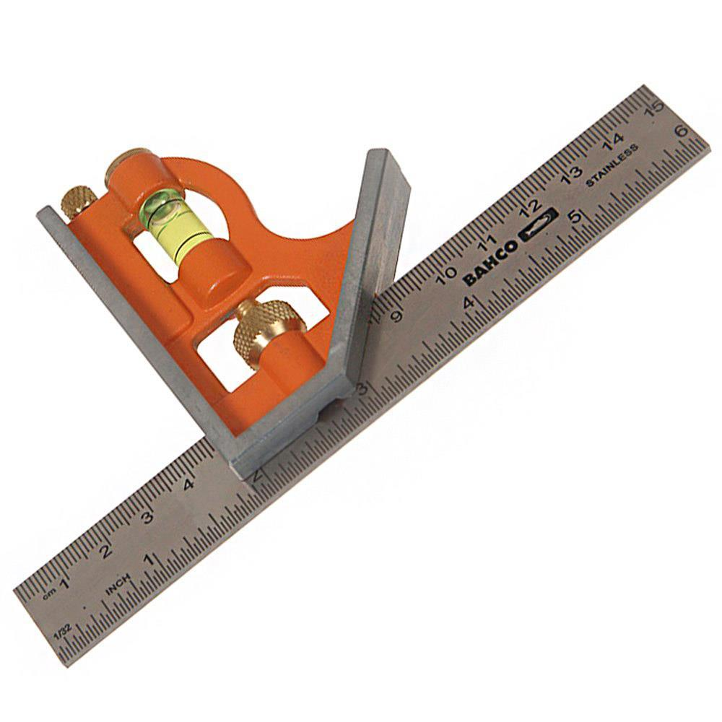
Description
The most commonly used head. It is designed to check and mark 90° and 45° angles.
Features
- 90° reference face
- 45° reference face
- Spirit level (many models)
- Scriber (many models)
Applications
- Checking squareness
- Marking right angles
- Measuring depth
- Measuring height

2. Protractor Head
# Source: AI Source: Provided by: [Data Path: Persons Table -> ID Column: 1, Name_En Column: Motasem Essam] -> From: [ChatGPT] on [7/17/2026]
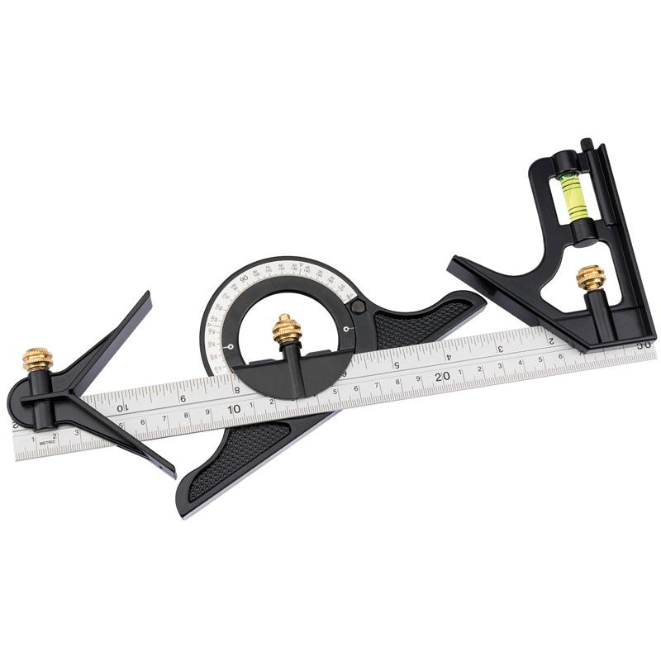

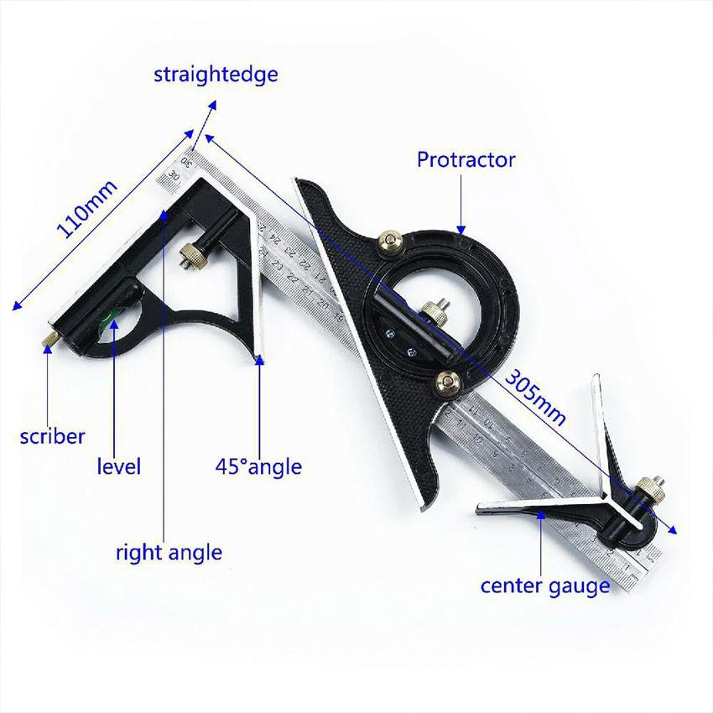
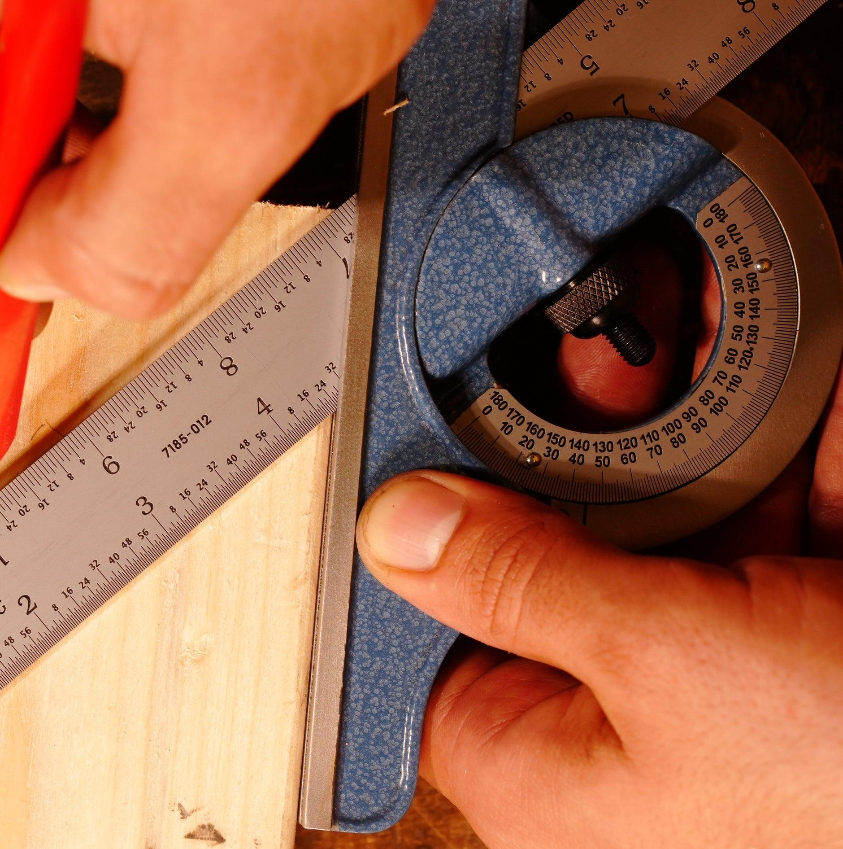
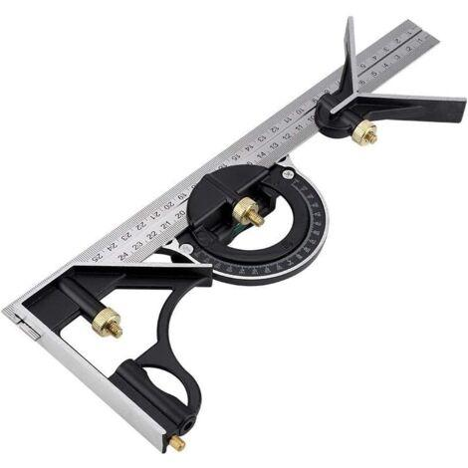
Description
Allows the rule to be set to any desired angle.
Measuring Range
- 0°–180° (or wider depending on the design)
Applications
- Measuring unknown angles
- Setting precise angles
- Engineering layout
- Machining

3. Center Head
# Source: AI Source: Provided by: [Data Path: Persons Table -> ID Column: 1, Name_En Column: Motasem Essam] -> From: [ChatGPT] on [7/17/2026]
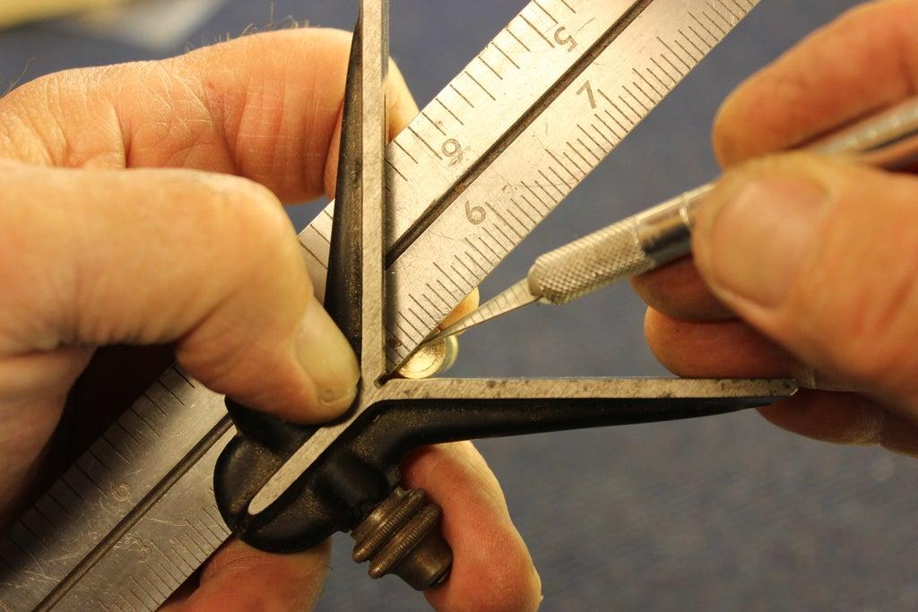
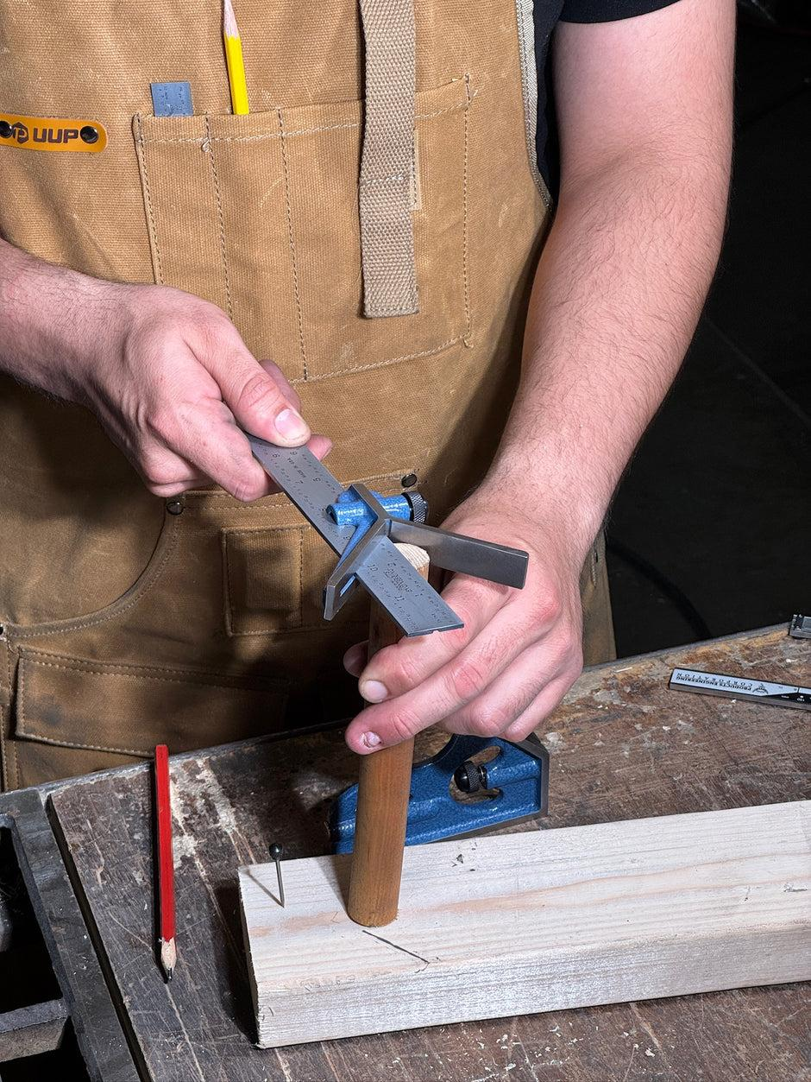
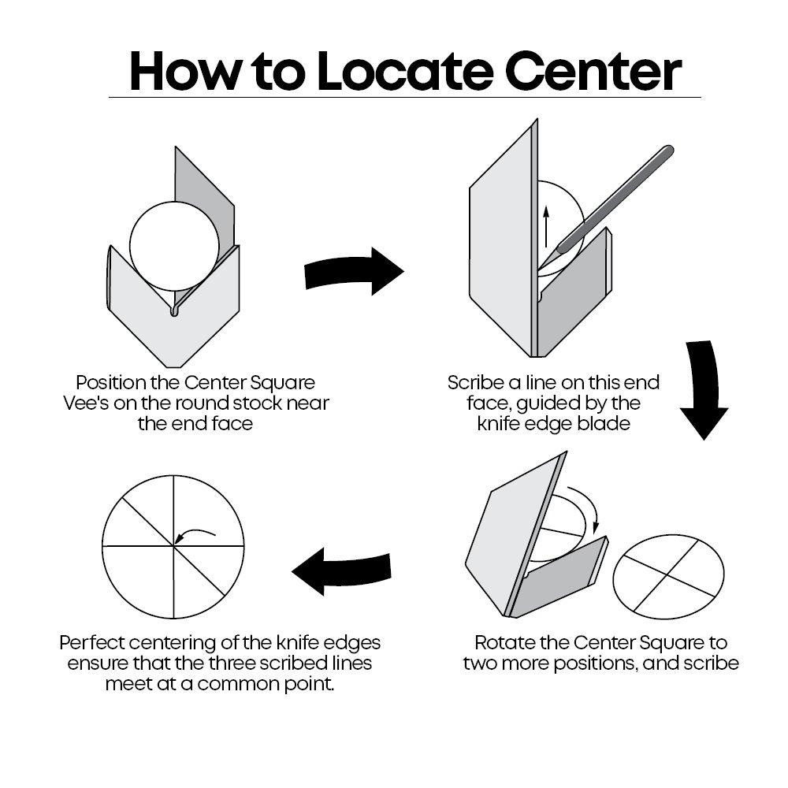
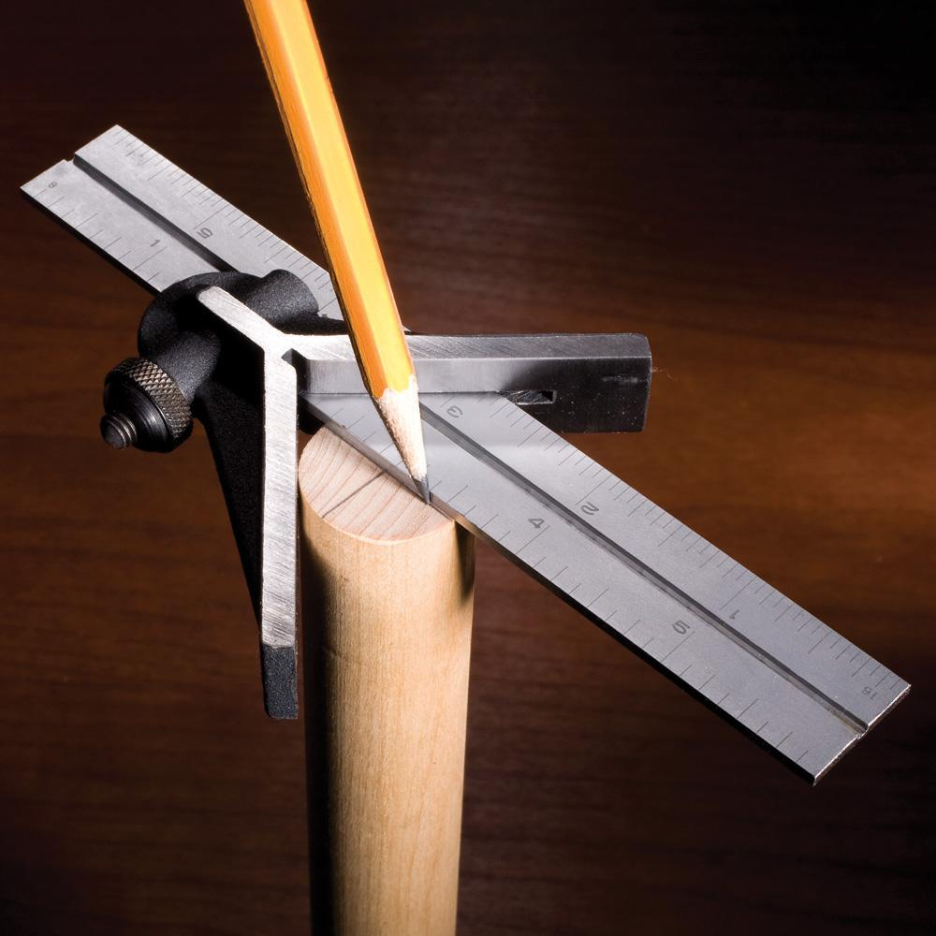
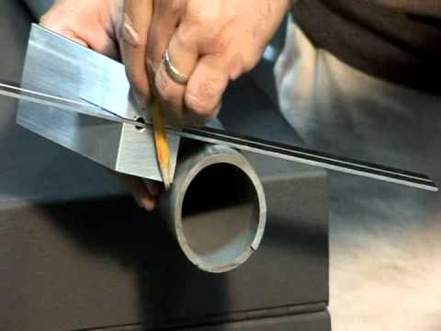
Description
Designed to locate the center of cylindrical or round workpieces.
Applications
- Finding shaft centers
- Pipe center marking
- Round stock layout

Measuring Range
# Source: AI Source: Provided by: [Data Path: Persons Table -> ID Column: 1, Name_En Column: Motasem Essam] -> From: [ChatGPT] on [7/17/2026]
The steel rule is commonly available in:
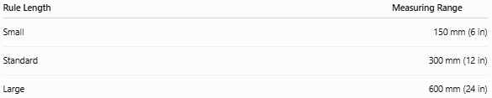
Rule Length | Measuring Range
Small | 150 mm (6 in)
Standard | 300 mm (12 in)
Large | 600 mm (24 in)

Least Count (Resolution)
# Source: AI Source: Provided by: [Data Path: Persons Table -> ID Column: 1, Name_En Column: Motasem Essam] -> From: [ChatGPT] on [7/17/2026]
Typical rule graduations:
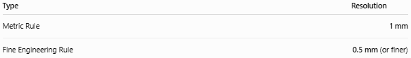
Type | Resolution
Metric Rule | 1 mm
Fine Engineering Rule | 0.5 mm (or finer)
The rule itself provides the resolution, while the heads enable accurate alignment and marking.

How to Use a Combination Square
# Source: AI Source: Provided by: [Data Path: Persons Table -> ID Column: 1, Name_En Column: Motasem Essam] -> From: [ChatGPT] on [7/17/2026]
Checking a 90° Angle
- Place the square head firmly against one surface.
- Bring the steel rule into contact with the adjacent surface.
- Check for any visible gap or misalignment.
Measuring Depth
- Extend the rule through the square head.
- Place the head on the reference surface.
- Lower the rule until it touches the bottom of the recess.
- Read the depth on the rule.
Marking a Line
- Lock the head at the desired position.
- Hold the head against the workpiece edge.
- Use the rule or scriber to draw a straight reference line.

Example
# Source: AI Source: Provided by: [Data Path: Persons Table -> ID Column: 1, Name_En Column: Motasem Essam] -> From: [ChatGPT] on [7/17/2026]
Suppose the steel rule is locked so that the distance from the square head to the end of the rule is:
78 mm
The measured or marked dimension is:
- 78 mm
- 7.8 cm
- 0.078 m

Accuracy
# Source: AI Source: Provided by: [Data Path: Persons Table -> ID Column: 1, Name_En Column: Motasem Essam] -> From: [ChatGPT] on [7/17/2026]
Typical accuracy depends on:
- Rule graduation quality
- Manufacturing precision
- Head alignment
- Locking mechanism
- Calibration
Good-quality combination squares are suitable for precision workshop measurements.

Sources of Error
# Source: AI Source: Provided by: [Data Path: Persons Table -> ID Column: 1, Name_En Column: Motasem Essam] -> From: [ChatGPT] on [7/17/2026]
Instrument Errors
- Worn rule graduations
- Loose locking mechanism
- Damaged head
- Bent steel rule

Observation Errors
- Reading the wrong graduation
- Parallax error

Positioning Errors
- Head not fully seated against the workpiece
- Rule not locked securely
- Improper alignment

Environmental Errors
- Dirt on contact surfaces
- Thermal expansion
- Surface damage

Applications
# Source: AI Source: Provided by: [Data Path: Persons Table -> ID Column: 1, Name_En Column: Motasem Essam] -> From: [ChatGPT] on [7/17/2026]
Combination Squares are widely used in:
- Carpentry
- Woodworking
- Mechanical engineering
- Machining
- Manufacturing
- Metalworking
- Construction
- Quality control
- Tool rooms
- Technical education

Advantages
# Source: AI Source: Provided by: [Data Path: Persons Table -> ID Column: 1, Name_En Column: Motasem Essam] -> From: [ChatGPT] on [7/17/2026]
A Combination Square:
- Combines several measuring tools into one.
- Checks both 90° and 45° angles.
- Measures depth and height.
- Performs layout marking.
- Is portable and durable.
- Offers interchangeable heads for different tasks.

Limitations
# Source: AI Source: Provided by: [Data Path: Persons Table -> ID Column: 1, Name_En Column: Motasem Essam] -> From: [ChatGPT] on [7/17/2026]
A Combination Square:
- Is less precise than specialized angle-measuring instruments for very fine angular measurements.
- Depends on proper head alignment.
- May require multiple heads for full functionality.
- Has a limited measuring range based on the rule length.

Comparison with Other Angle Measuring Instruments
# Source: AI Source: Provided by: [Data Path: Persons Table -> ID Column: 1, Name_En Column: Motasem Essam] -> From: [ChatGPT] on [7/17/2026]
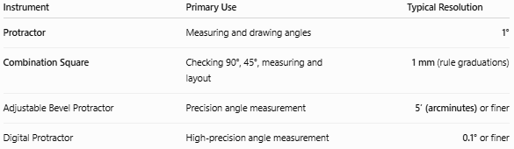
Instrument | Primary Use | Typical Resolution
Protractor | Measuring and drawing angles | 1°
Combination Square | Checking 90°, 45°, measuring and layout | 1 mm (rule graduations)
Adjustable Bevel Protractor | Precision angle measurement | 5′ (arcminutes) or finer
Digital Protractor | High-precision angle measurement | 0.1° or finer

Care and Maintenance
# Source: AI Source: Provided by: [Data Path: Persons Table -> ID Column: 1, Name_En Column: Motasem Essam] -> From: [ChatGPT] on [7/17/2026]
To maintain accuracy:
- Keep the steel rule clean.
- Protect the rule from bending.
- Tighten the locking mechanism properly.
- Store the heads in a protective case.
- Check the square head periodically against a known right angle.
- Lightly oil steel components when recommended.

Common Mistakes
# Source: AI Source: Provided by: [Data Path: Persons Table -> ID Column: 1, Name_En Column: Motasem Essam] -> From: [ChatGPT] on [7/17/2026]
- Not tightening the locking screw.
- Measuring with a loose head.
- Using a damaged rule.
- Failing to fully seat the head against the reference surface.
- Reading the wrong graduation.

Key Points
# Source: AI Source: Provided by: [Data Path: Persons Table -> ID Column: 1, Name_En Column: Motasem Essam] -> From: [ChatGPT] on [7/17/2026]
- A Combination Square is a multi-purpose measuring and layout instrument.
- It consists of a steel rule and interchangeable heads.
- Common heads include:
  - Square Head
  - Protractor Head
  - Center Head
- It is used to:
  - Measure length
  - Measure depth
  - Check 90° and 45° angles
  - Measure adjustable angles
  - Locate the center of round workpieces
- It is widely used in engineering, woodworking, machining, manufacturing, and construction.

Conclusion
# Source: AI Source: Provided by: [Data Path: Persons Table -> ID Column: 1, Name_En Column: Motasem Essam] -> From: [ChatGPT] on [7/17/2026]
A Combination Square is one of the most versatile measuring and layout tools used in engineering and workshop environments. By combining a graduated steel rule with interchangeable square, protractor, and center heads, it supports a wide range of tasks including measuring lengths, checking right and 45° angles, measuring depths, marking layouts, locating centers, and setting adjustable angles. Its versatility, portability, and precision make it an essential instrument for carpenters, machinists, engineers, inspectors, and technicians.

